Military Survey (Geographic) Association
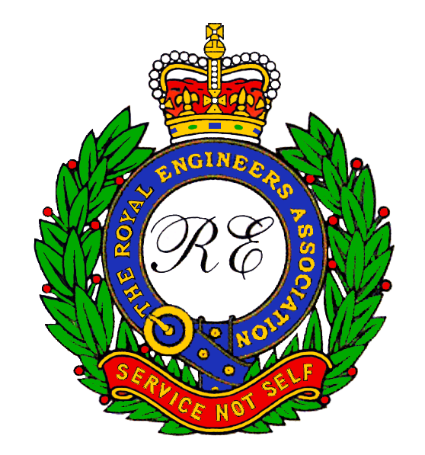
A member of the Royal Engineers Association

MINUTES OF THE 13th ANNUAL GENERAL MEETING
held at the
WOs’ & Sgts’ Mess, Denison Barracks, Hermitage
on
Friday 7th September 2012, at 1900hrs

In Attendance:
President: Bob Avenell
Chairman: Angus Cross
Secretary: Rod Siggs
Treasurer: Alf Isherwood
Military Representative: WO1 (RSM) W Robinson RE
Function Co-ordinator: Mick Perry

27 Members were present. A list is attached.

ITEM 1 – CHAIRMAN’S OPENING REMARKS

The Chairman welcomed those present, remarking on the good turnout and thanking them for their attendance, especially Keith (Joe) Brown, who had travelled from Oman to be at the AGM for the first time. He outlined the evening’s format which was to be preceded with the customary briefing from the Commander Joint Aeronautical and Geospatial Organisation (JAGO) on current Geo matters followed by the presentation of the Association’s Annual Award. He again stressed that he would keep the AGM to the minimum possible and said the important parts had all been circulated by the Newsletter, Website and had also been displayed on the notice board prior to the meeting. He then introduced Col M Burrows.

Col Burrows gave a comprehensive update on Geo matters which is to be published in Newsletter.

Following the Geo update the President, Bob Avenell, presented the Annual Award to Spr Dale Jones on behalf of the Association. The citation will be published in the Newsletter.

ITEM 2 – APOLOGIES

The names of those members who had tendered their apologies were listed on the notice board and are attached.

ITEM 3 – MINUTES OF THE 12th ANNUAL GENERAL MEETING (AGM) 2011

The minutes of the last AGM had previously been published on the Branch website, printed in the Newsletter, and were also available on the notice board prior to this AGM. The Chairman asked if there were any comments, errors or omissions from the floor. As there were none, he asked for a proposer that they be accepted as a true record of that meeting:

Proposed: Jim Hyde
Seconded by: John Hughes
Carried unanimously.

ITEM 4 – ANNUAL REPORT ON 2011/2012

- The Chairman reported that during 2011/2012, membership had remained relatively stable at approximately 350 despite seeming to be frequently sent “sad news”. The names of those deceased comrades, friends and colleagues that we have been notified of since the last AGM, appear on the notice board. But he asked if anyone knew of any others then they should let the Secretary know.
- The Standard Bearers have turned out four times for funerals and each time they had been thoroughly appreciated. Our thanks go to Mike Payne, Mick Nottage and Jack Crompton for undertaking these duties. Mike has submitted an annual report which will be presented by Mick Nottage later in the meeting.
- The Chairman stated that although the Treasurers Summary would follow, the overall position is that we are “fit and healthy”. We have paid for the production of the Photo Database of the RSMS Course photos which had required a lot of work and brain power to reach this stage. However, it needs a little refining with our help regarding names etc.. A demonstration of the database would be given after the AGM by Dave Johnson and Alan Gordon. There had been no call on the Soldiers Fund for support this year because the COPF was a lot healthier than it had previously been. However, he thought the Fund would be called upon to support our Soldiers in the near future as the move is likely to throw up various requirements. He was, therefore, not unduly worried that we had nil spends this year.
- He said that the name change from “Branch” to “Association” suggested by the Committee (the rationale for which has been expounded at the previous AGM and in the Newsletters), must be voted upon. He said it had led some to the perception that we are leaving the REA, which we most definitely are not.
However, before the vote there was a comment from the floor that it seemed we were straying from the REA principles and were becoming insular. In the discussions that followed it was reiterated that we were only changing our name to try and gain more members who seem to have an adverse perception of the REA. We therefore wished to give the REA less prominence in our title but our involvement with the REA will not be diminished. A majority vote was then carried to adopt the name of The Military Survey (Geographic) Association.
- The Chairman spoke of the reason for the separation of the AGMs and Reunions – “It is a legal requirement that we hold an AGM to vote upon the Audited Accounts”, he said. However, a concerted effort had been made to reduce the AGMs to the barest requirement but it is accepted that many still do not wish to travel any distance to sit through the formal procedures (even with a get together afterwards). The reunions are therefore going to be the main platform to get us together and for which the organisation was originally formed. By having separate functions it is hoped to encourage the membership to attend the reunions again in the numbers that were seen at our organisation’s conception. The Chairman explained that accordingly the next AGM would be held early in 2013, following the audited accounts, but the next reunion would not be held until 2014, when it was hoped we would join in with an event to mark the Regiment’s withdrawal from Hermitage.
- The Chairman then said that there was nothing more of significance to report but thanked Alan Gordon for a very successful Newsletter which was continually enjoyed by all members. He said that all organisations were struggling to retain members, or gain involvement of their membership, as were the Defence Surveyors Association (DSA), and there might be a consideration in the future for some form of amalgamation.

ITEM 5 – FINANCIAL STATUS

The Treasurer Alf Isherwood gave a résumé of the Audited Accounts of the Association and Auditors Comments which had previously been displayed in the Newsletter, on the website and had been attached to the noticeboard, prior to the meeting. This gave rise to a question from the floor as to how a sum of money could be both an Asset and a Liability (this concerned the Soldiers Fund).
This provoked a lengthy discussion from which it was finally agreed that the accounts had been audited and found to be satisfactory but a definitive answer would be given to the Membership which is attached to these minutes.

Accordingly, it was proposed that the Accounts be accepted.
Proposed by: Ken Hall
Seconded by: Mick Perry
Carried by a majority.

Alf then gave the headline statistics of the Associations current finances as at 5 Oct 2012:

Current Account £969.18
Savings Account £7,718.89
Total £8,688.07

Geo Sldrs Fund £2,498.61

Anticipated spend £3,450.00

Working Capital £5,238.07

Debtors (written off) £8.00
Outstanding from 2011 £32.00

Current subs for 2012 £2,072.00

ITEM 6 - ELECTION OF AUDITOR/INDEPENDENT EXAMINER 2012/2013

The Chairman explained that in order to maintain probity during the next FY, it was necessary to elect an Auditor/Independent Examiner of the Account. Maj A Keeley (Retd)
has volunteered to undertake this duty on behalf of the Branch and the Chairman asked for a proposer and seconder to elect him.

Proposed by: Mike Gowlett
Seconded by: Mick Perry
Carried unanimously.

ITEM 7 – COMMITTEE

The President, Bob Avenell, thanked the present Committee for their hard work throughout another year but he informed the members that the three Officers of the Committee, the Chairman, Treasurer and Secretary, had to be elected each year. He went on to thank Dave Johnson for running such a superb website and Alan Gordon for continually producing such an eagerly awaited Newsletter and both of them for their hard work in producing the RSMS Course Database. He also thanked Alf Isherwood and Rod Siggs for undertaking their duties so diligently and he both welcomed the RSM, WO1 Will Robinson, to the Committee and also for allowing us to continually use his facilities. He asked him to pass on his thanks to WO2 Noel and SSgt Sargeant for their support to Mick Perry without whom there would not have been the AGM and post meeting buffet.
Bob, said he had approached the three Committee Officers who were all willing to stand again and therefore, unless there were any different nominations from the floor, he would ask that all three be re-elected en bloc. Carried unanimously.

The President concluded by speaking about the need for good governance and the requirements for new blood and for support, or we will fade and die as an organisation.

ITEM 8 – STANDARD BEARERS REPORT

Mick Nottage read out the Standard Bearers report from Mike Payne, attached to these minutes. The Chairman asked that a vote of thanks to the Standard Bearers be recorded.

ITEM 9 – AOB

There had been no written matters put forward to the Secretary prior to the meeting and there were none raised at the meeting.

ITEM 10 – DATE AND VENUE OF NEXT MEETING

No date, or agreement, has been fixed at the moment but the next meeting will take place in spring, 2013, as previously discussed, at Hermitage.

ITEM 11 – CLOSING REMARKS

The President thanked all members for attending the meeting and for such a lively debate.

The meeting closed at approximately 2012 hrs.

Rod Siggs

Honorary Secretary
Military Survey (Geographic) Branch
Royal Engineers Association

